1. ***Software for Storage – One Drive***
2. ***Software for Dangerous Tasks Program – NHS App***
3. ***Software for Social Media Program - Instagram***
4. ***Software for Search Engine Program - Google***
5. ***Software for Applications – Productivity – Office Suite***
6. ***Software for Entertainment – YouTube***

***Requirements for Each Program:***

***Purpose***

***Screenshots with animation***

***Try to find out what programming language is used to create the application***

***Compare similar applications***

***Purpose***

***Screenshots with animation***

***Try to find out what programming language is used to create the application***

***Compare similar applications***

1. ***One Drive:***

One drive is used in order to store or backup any type of data all the way from photos, videos, music or even important documents. It serves a big purpose in a lot of people’s lives from day to day tasks or even strictly backing up data daily, weekly or monthly. One Drive was made using C++ alongside the majority of other applications that Microsoft has created. There’s a lot of programs that are extremely similar to One Drive such as: Google Drive, Mega, Dropbox, Apple iCloud and a very large collection of others that peform very similary to One Drive with each program having its own benefits and drawbacks.

[6]

[5]

[4]

[3]

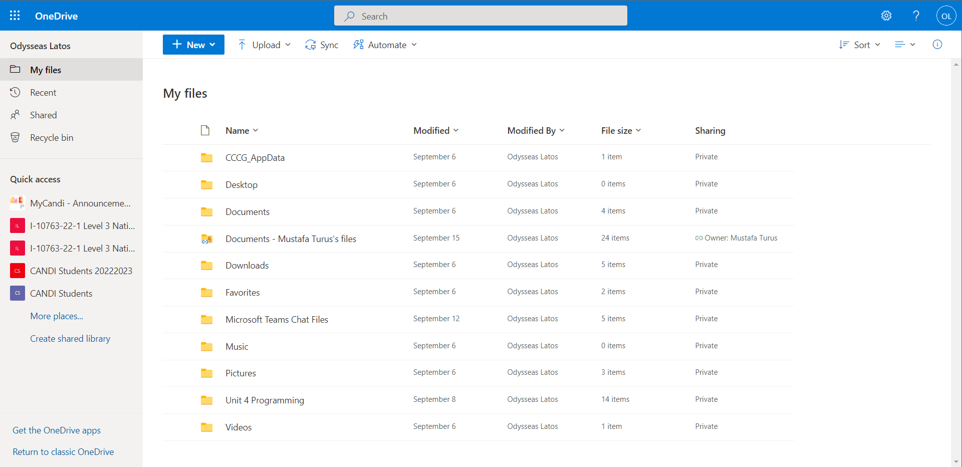

[8]

[9]

[7]

[2]

[1]

This is a screenshot of One Drive even though it might seem bloated with options to choose from its very straightforward and self-explanatory. [1] Is the list of directories that include files and the recycle bin where you can access any file that has been deleted up to 30 days ago. [2] Is the quick access tab which shows any directory or folders that you have recently accessed. [3] Is where you can upload or create new files within your One Drive folder. [4] The search bar is where you can search for any file or folder name that you have accessed or you own within One Drive. [5] Is a gear which means the settings where you can accessing settings that are relevant to tweaking your One Drive to your liking. [6] The question mark is for the Help section where you can make or search for any queries regarding a concern or issue you might have. [7] Where you profile picture is displayed and be used to access your account settings or where you can sign out. [8] You can sort your displayed file and documents by newest, oldest, largest, smallest and etc. [9] Takes the most space up since it displays your drive or the current directory that you are currently browsing.

1. ***The NHS App***

The NHS App is an app used to keep track of everything that has to do with you and your health record, upcoming appointments, prescriptions and a handful of other things that have to do with your health The programming language used to make this app has not been listed online but it’s most likely to be Java due to the fact that Java makes up more than 60% of phone apps made. There aren’t really any apps that are similar to this application apart from other apps the NHS has made like My GP and Covid 19 Pass.

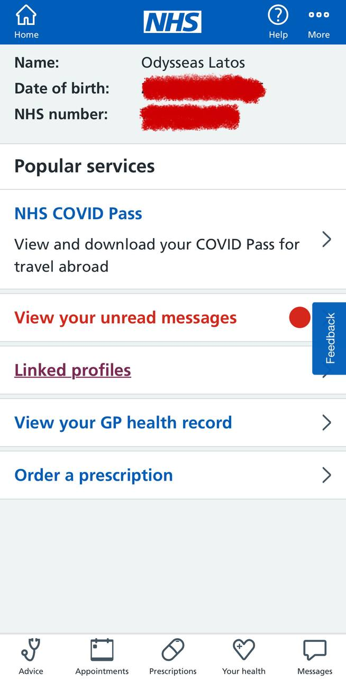

[1]

[4]

[2]

[5]

[3]

[6]

[7]

NHS App is a very simple app and this can be inferred purely from its layout and use of logos instead of overly complicated terms for simple things. [1] The home button which is used to take you back to starting screen no matter the current phase. [2] This lists three very basic but important details to the patient which include their full name, date of birth and NHS Number. [3] Is a list of the current popular services within the app such as your COVID Pass and your unread messages. [4] The three dots infer the app settings as they usually do in almost every app. [5] The question mark is for the help section where you can make or search for any queries regarding a concern or issue you might have. [6] The feedback button is very self-explanatory as to what it was which collect feedback based on your experience with the app. [7] The dashboard where it has a collection of features such as tabs on: Advice, Appointments, Prescriptions, Your Health and Messages which is very useful for quickly accessing the following listed above.

[7]

1. 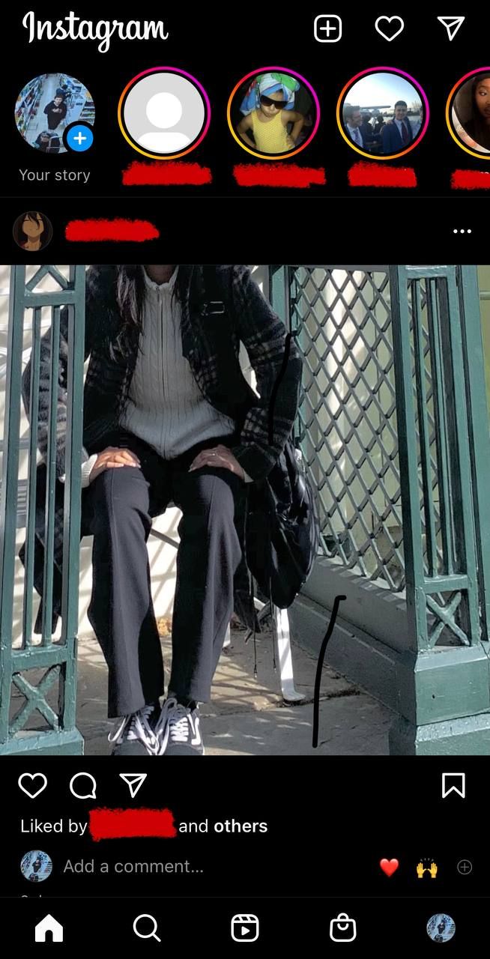***Instagram***

Instagram is a social media platform that is used to livestream and upload photos, videos to your feed or your story which unlike your feed it has a time limit of 24 hours to view. This program is used by around a billion users monthly, they can communicate with each other using DM’s also known as Direct Messages. Instagram was created using the programming language called python. There’s not a shortage of social media applications similar to Instagram such as: Facebook, Snapchat, Twitter and handful of others.

[10]

[6]

[5]

[9]

[8]

[4]

[3]

[2]

[1]